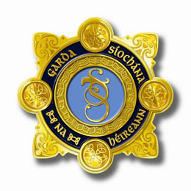

Tullamore and District Chamber of Commerce and An Garda Síochána

Business Watch Group Scheme

The Tullamore and District Chamber of Commerce are currently working on a joint initiative alongside An Garda Síochana to introduce a business group watch scheme.
In summary, each street will have two representatives and a WhatsApp text messaging group will be created as a means of communication between the street members. As a result, instant real time information will become available on any undesirable activities happening throughout the town. For more information on this Business Group Watch Scheme, please see document attached.
The contact information provided will also be used as an information and communication tool for future town promotions and events.
Please complete all attached documents and return to your Business Street Rep.

Anthony Kearns & Brian Cloonan

Business Group Watch Scheme Contact Information:

Business Name: ______________________________

Contact 1

Name: _____________________________________
Phone Number: ______________________________
Email: ______________________________________

Contact 2 (If Applicable)

Name: _____________________________________
Phone Number: ______________________________
Email: ______________________________________

